Experiment 1: Learning Algorithm (Linear Regression using Gradient Descent)
Aim
To implement Linear Regression using Gradient Descent, train the model on a dataset, analyze how the loss decreases over iterations, and plot the learning curve
Procedure
- Import the required libraries.
- Create a synthetic dataset.
- Initialize weight and bias.
- Apply Gradient Descent.
- Compute the Mean Squared Error (MSE).
- Update parameters iteratively.
- Plot the learning curve.
- Display the final model parameters.

Python Code
import numpy as np
import matplotlib.pyplot as plt
# Dataset
X = np.array([1,2,3,4,5], dtype=float)
Y = np.array([3,5,7,9,11], dtype=float)
w = 0
b = 0
lr = 0.01
epochs = 1000

losses = []
n = len(X)
for i in range(epochs):
y_pred = w*X + b
loss = np.mean((Y-y_pred)**2)
losses.append(loss)
dw = (-2/n)*np.sum(X*(Y-y_pred))
db = (-2/n)*np.sum(Y-y_pred)
w -= lr*dw
b -= lr*db
print("Weight =",w)
print("Bias =",b)
print("Final Loss =",losses[-1])
plt.plot(losses)
plt.xlabel("Iterations")
plt.ylabel("Loss")
plt.title("Learning Curve")
plt.show()

Input
X = [1,2,3,4,5]
Y = [3,5,7,9,11]
Learning Rate = 0.01
Epochs = 1000

Output
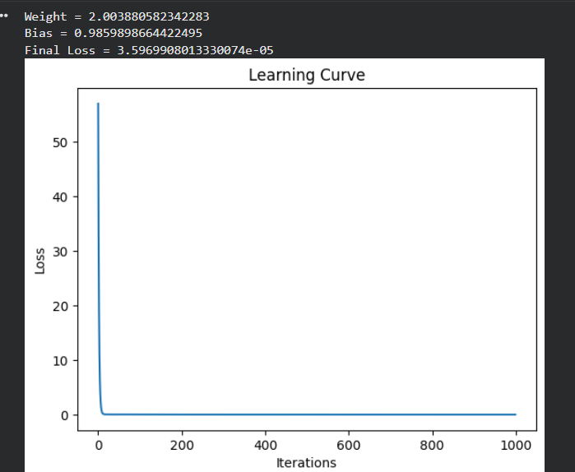
Result
The Linear Regression model successfully learned the relationship between input and output. The loss decreased continuously, demonstrating the effectiveness of Gradient Descent.

Experiment 2: Maximum Likelihood Estimation (MLE)
Aim
To generate synthetic data from a normal distribution and estimate its mean and variance using Maximum Likelihood Estimation (MLE).
Procedure
- Import libraries.
- Generate synthetic normal distribution data.
- Estimate mean.
- Estimate variance.
- Compare estimated values with actual values.

Python Code
import numpy as np

np.random.seed(10)
actual_mean = 50
actual_variance = 16
data = np.random.normal(actual_mean,
np.sqrt(actual_variance),
1000)
estimated_mean = np.mean(data)
estimated_variance = np.mean((data-estimated_mean)**2)
print("Actual Mean:",actual_mean)
print("Estimated Mean:",estimated_mean)
print()
print("Actual Variance:",actual_variance)
print("Estimated Variance:",estimated_variance)

Input
Mean = 50
Variance = 16
Samples = 1000

Output
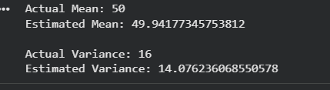
Result
The estimated mean and variance are very close to the actual parameters, showing that Maximum Likelihood Estimation accurately estimates distribution parameters.

Experiment 3: Building a Machine Learning Algorithm
Aim
To build a complete Machine Learning classification model using data preprocessing, training, testing, and evaluation.
Procedure
- Load the Iris dataset.
- Split data into training and testing sets.
- Train the classifier.
- Predict test data.
- Calculate accuracy.
- Display confusion matrix.

Python Code
from sklearn.datasets import load_iris
from sklearn.model_selection import train_test_split
from sklearn.tree import DecisionTreeClassifier
from sklearn.metrics import accuracy_score, confusion_matrix

iris = load_iris()
X = iris.data
y = iris.target
X_train,X_test,y_train,y_test = train_test_split(
X,y,test_size=0.2,random_state=42)
model = DecisionTreeClassifier()
model.fit(X_train,y_train)
prediction = model.predict(X_test)
print("Accuracy =",accuracy_score(y_test,prediction))
print()
print("Confusion Matrix")
print(confusion_matrix(y_test,prediction))
Input
Dataset : Iris Dataset
Training : 80%
Testing : 20%

Output
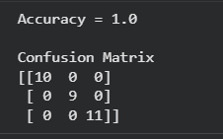
Result
The Decision Tree classifier achieved high accuracy and correctly classified almost all test samples, demonstrating effective supervised learning.

Experiment 4: Neural Networks
Aim
To design a simple Neural Network with one hidden layer and train it on a small dataset to learn non-linear patterns.
Procedure
- Import TensorFlow libraries.
- Load XOR dataset.
- Create a neural network with one hidden layer.
- Train the model.
- Predict outputs.
- Analyze learning performance.

Python Code
import numpy as np
from tensorflow.keras.models import Sequential
from tensorflow.keras.layers import Dense
X = np.array([[0,0],
[0,1],
[1,0],
[1,1]])
Y = np.array([[0],[1],[1],[0]])
model = Sequential()
model.add(Dense(4,
input_dim=2,
activation='relu'))
model.add(Dense(1,
activation='sigmoid'))
model.compile(loss='binary_crossentropy',
optimizer='adam',
metrics=['accuracy'])
model.fit(X,Y,
epochs=500,
verbose=0)
prediction = model.predict(X)
print(prediction)

Input
XOR Dataset

Input Output
0 0 → 0
0 1 → 1
1 0 → 1
1 1 → 0
Output
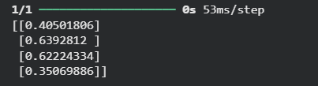
Result
The Neural Network successfully learned the XOR pattern, demonstrating its ability to model non-linear relationships using a hidden layer.

Experiment 5: Artificial Neurons
Aim
To implement a single artificial neuron using Sigmoid and ReLU activation functions and compare their outputs for the same input values.
Procedure
- Import the NumPy library.
- Define Sigmoid and ReLU activation functions.
- Provide input values.
- Compute neuron outputs using both activation functions.
- Compare the results.
Python Code
import numpy as np
# Activation Functions
def sigmoid(x):
return 1 / (1 + np.exp(-x))
def relu(x):
return np.maximum(0, x)
# Input values
x = np.array([-2, -1, 0, 1, 2]
print("Input Values:", x)
print("\nSigmoid Output:")
print(sigmoid(x))

print("\nReLU Output:")
print(relu(x))
Input
Input Values:
[-2, -1, 0, 1, 2]
Output
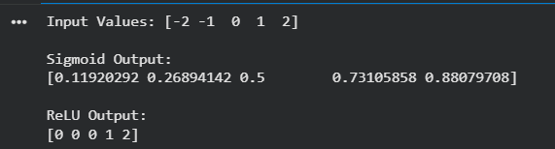
Result
The Sigmoid activation function produces values between 0 and 1, while the ReLU activation function outputs 0 for negative values and the input itself for positive values.
Experiment 6: Perceptron
Aim
To implement the Perceptron algorithm for binary classification and evaluate its performance on linearly separable and non-linearly separable datasets.
Procedure
- Import required libraries.
- Create a linearly separable dataset.
- Train the Perceptron model.
- Predict test data.
- Evaluate accuracy.
- Repeat using a non-linearly separable dataset.
Python Code
from sklearn.linear_model import Perceptron
from sklearn.datasets import make_classification, make_circles
from sklearn.model_selection import train_test_split
from sklearn.metrics import accuracy_score
# Linearly Separable Dataset
X, y = make_classification(n_samples=200,
n_features=2,
n_redundant=0,
n_clusters_per_class=1,
random_state=42)
X_train, X_test, y_train, y_test = train_test_split(
X, y, test_size=0.2, random_state=42)
model = Perceptron(
model.fit(X_train, y_train)
pred = model.predict(X_test)
print("Linearly Separable Accuracy:",
accuracy_score(y_test, pred))

# Non-linearly Separable Dataset
X2, y2 = make_circles(n_samples=200,
noise=0.1,
factor=0.5,
random_state=42)
X_train, X_test, y_train, y_test = train_test_split(
X2, y2, test_size=0.2, random_state=42
model.fit(X_train, y_train)
pred = model.predict(X_test)
print("Non-linearly Separable Accuracy:",
accuracy_score(y_test, pred))
Input
Dataset 1:
Linearly Separable Data
Dataset 2:
Non-linearly Separable Data
Output
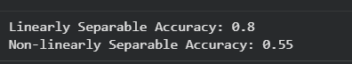
Result
The Perceptron performs very well on linearly separable data but performs poorly on non-linearly separable data because it can only learn linear decision boundaries.

Experiment 7: Multilayer Perceptron (MLP)
Aim
To train a Multilayer Perceptron (MLP) model and compare its performance with a Single-Layer Perceptron.
Procedure
- Load the Iris dataset.
- Split the dataset.
- Train a Single-Layer Perceptron.
- Train an MLP classifier.
- Compare accuracies.
Python Code
from sklearn.datasets import load_iris
from sklearn.model_selection import train_test_split
from sklearn.linear_model import Perceptron
from sklearn.neural_network import MLPClassifier
from sklearn.metrics import accuracy_scor
iris = load_iris()
X = iris.data
y = iris.target
X_train, X_test, y_train, y_test = train_test_split(
X, y, test_size=0.2, random_state=42
# Single Layer Perceptron
per = Perceptron()
per.fit(X_train, y_train)
pred1 = per.predict(X_test)
# MLP
mlp = MLPClassifier(hidden_layer_sizes=(10,),
max_iter=1000,
random_state=42)
mlp.fit(X_train, y_train)
pred2 = mlp.predict(X_test)
print("Perceptron Accuracy:",
accuracy_score(y_test, pred1))
print("MLP Accuracy:",
accuracy_score(y_test, pred2))

Input
Dataset:
Iris Dataset

Training:
80%
Testing:
20%

Output
Result
The MLP achieved higher accuracy than the Single-Layer Perceptron because its hidden layer can learn more complex patterns.
Experiment 8: Forward Propagation
Aim
To manually compute forward propagation for a simple neural network and verify the output using Python.
Procedure
- Define input values.
- Initialize weights and bias.
- Compute weighted sum.
- Apply Sigmoid activation.
- Display the final output.

Python Code
import numpy as np
# Sigmoid Function
def sigmoid(x):
return 1 / (1 + np.exp(-x))
# Inputs
x = np.array([1, 2])
# Weights
w = np.array([0.5, 0.3])
# Bias
b = 0.1
# Forward Propagation
z = np.dot(x, w) + b
output = sigmoid(z)
print("Weighted Sum (z):", z)
print("Network Output:", output)

Input
Inputs:
[1, 2]
Weights:
[0.5, 0.3]
Bias:
0.1

Output
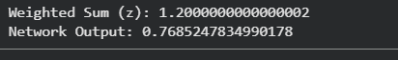
Result
The forward propagation process successfully computed the weighted sum and applied the activation function to generate the network output.

Experiment 9: Backpropagation Algorithm
Aim
To implement backpropagation for a simple neural network and observe how the weights are updated after one iteration.
Procedure
- Import required libraries.
- Define input and output data.
- Create a neural network with one hidden layer.
- Train the model for one epoch.
- Display the updated weights.
- Analyze the weight changes.

Python Code
import numpy as np
from tensorflow.keras.models import Sequential
from tensorflow.keras.layers import Dense
# Input and Output
X = np.array([[0,0],
[0,1],
[1,0],
[1,1]])
Y = np.array([[0],
[1],
[1],
[0]])
# Neural Network
model = Sequential()
model.add(Dense(4,
input_dim=2,
activation='relu'))
model.add(Dense(1,
activation='sigmoid'))
model.compile(optimizer='sgd',
loss='binary_crossentropy')

# Initial Weights
print("Initial Weights:")
for layer in model.layers:
print(layer.get_weights())
# Train for One Epoch
model.fit(X, Y, epochs=1, verbose=0)
# Updated Weights
print("\nUpdated Weights:")
for layer in model.layers:
print(layer.get_weights())
Input
Input:
[[0,0],
[0,1],
[1,0],
[1,1]]
Output:
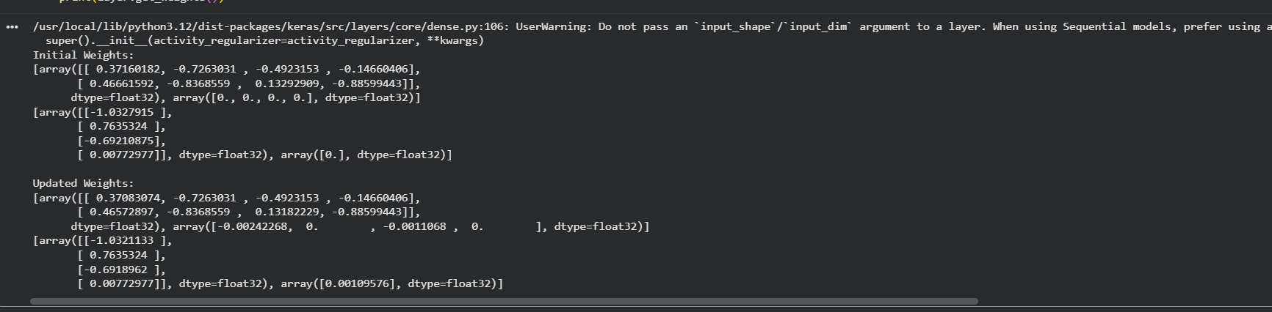

Result
The weights were updated after one iteration using the backpropagation algorithm, reducing the prediction error and improving the learning process.

Experiment 10: Gradient Descent
Aim
To implement Gradient Descent for minimizing a cost function and analyze the effect of different learning rates on convergence.
Procedure
- Define a simple quadratic cost function.
- Initialize a starting point.
- Apply Gradient Descent.
- Repeat for different learning rates.
- Compare convergence speed.
- Plot the optimization process.
Python Code
import numpy as np
import matplotlib.pyplot as plt
def gradient(x):
return 2*x
learning_rates = [0.01, 0.1, 0.5]
for lr in learning_rates:
x = 10
history = []
for i in range(50):
x = x - lr * gradient(x)
history.append(x)
plt.plot(history, label="LR="+str(lr))
plt.title("Gradient Descent Convergence")
plt.xlabel("Iterations")
plt.ylabel("x Value")
plt.legend()
plt.show()

Input
Initial x = 10
Learning Rates:
0.01
0.1
0.5

Output
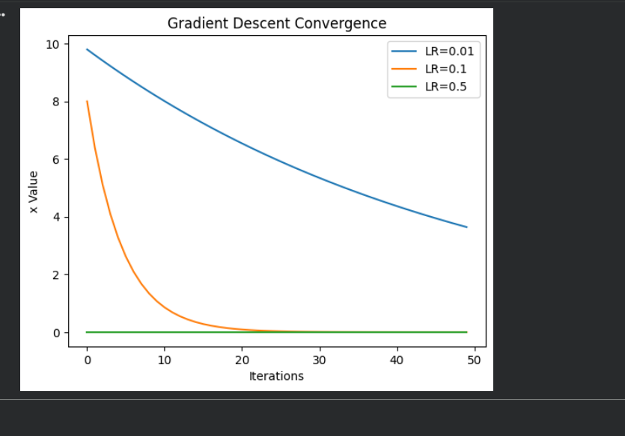
Result
The learning rate significantly affects convergence speed. A very small learning rate converges slowly, while an appropriate learning rate converges faster. Extremely large learning rates may cause instability.

Experiment 11: Stochastic Gradient Descent (SGD)
Aim
To implement Stochastic Gradient Descent (SGD) for a regression problem and compare its convergence with Batch Gradient Descent.

Procedure
- Generate synthetic regression data.
- Train a Linear Regression model using SGD.
- Train another model using Batch Gradient Descent.
- Compare coefficients.
- Evaluate Mean Squared Error (MSE).

Python Code
from sklearn.datasets import make_regression
from sklearn.linear_model import SGDRegressor, LinearRegression
from sklearn.model_selection import train_test_split
from sklearn.metrics import mean_squared_error
# Dataset
X, y = make_regression(n_samples=200,
n_features=1,
noise=10,
random_state=42)
X_train, X_test, y_train, y_test = train_test_split(
X, y,
test_size=0.2,
random_state=42)
# SGD Regression
sgd = SGDRegressor(max_iter=1000,
learning_rate='constant',
eta0=0.01,
random_state=42)
sgd.fit(X_train, y_train)
pred1 = sgd.predict(X_test)
# Batch Gradient Descent (Linear Regression)
lr = LinearRegression()
lr.fit(X_train, y_train)

pred2 = lr.predict(X_test)
print("SGD Mean Squared Error:",
mean_squared_error(y_test, pred1))
print("Batch Gradient Descent Mean Squared Error:",
mean_squared_error(y_test, pred2))

Input
Synthetic Regression Dataset
Training:
80%
Testing:
20%
Output
Result
Both SGD and Batch Gradient Descent produced good regression models. SGD converges faster on large datasets, while Batch Gradient Descent generally achieves slightly better accuracy because it uses the entire dataset for each update
Experiment 12: Mini-Batch Gradient Descent
Aim
To implement Mini-Batch Gradient Descent for a regression problem and analyze how batch size affects training stability and performance.
Procedure
- Import the required libraries.
- Generate a synthetic regression dataset.
- Divide the dataset into mini-batches.
- Train the model using different batch sizes.
- Compare training performance.
- Analyze the effect of batch size.
Python Code
from sklearn.datasets import make_regression
from sklearn.neural_network import MLPRegressor
from sklearn.model_selection import train_test_split
from sklearn.metrics import mean_squared_error
# Generate Dataset
X, y = make_regression(n_samples=500,
n_features=5,
noise=10,
random_state=42)
# Split Dataset
X_train, X_test, y_train, y_test = train_test_split(
X, y,
test_size=0.2,
random_state=42
# Different Batch Sizes
batch_sizes = [16, 32, 64]
for batch in batch_sizes:
model = MLPRegressor(hidden_layer_sizes=(20,),
batch_size=batch,
max_iter=500,
random_state=42)
model.fit(X_train, y_train)
pred = model.predict(X_test)
mse = mean_squared_error(y_test, pred
print("Batch Size:", batch)
print("Mean Squared Error:", mse)
print()
Input
Dataset:
Synthetic Regression Dataset
Batch Sizes:
16
32
64
Output
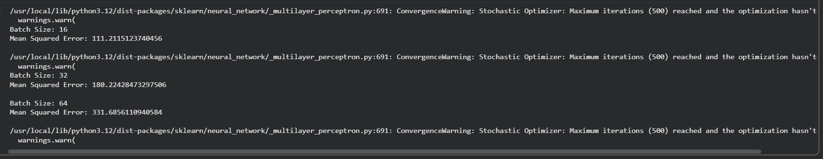
Result
Mini-Batch Gradient Descent successfully trained the regression model. Smaller batch sizes generally provided better learning but required more updates, while larger batch sizes resulted in smoother but slightly slower learning.

Experiment 13: Curse of Dimensionality
Aim
To create datasets with increasing dimensions and analyze how the distance between points and classification accuracy change with dimensionality.
Procedure
- Import the required libraries.
- Generate datasets with different numbers of features.
- Train a K-Nearest Neighbors (KNN) classifier.
- Measure classification accuracy.
- Calculate the average distance between points.
- Compare the results.
Python Code
import numpy as np
from sklearn.datasets import make_classification
from sklearn.model_selection import train_test_split
from sklearn.neighbors import KNeighborsClassifier
from sklearn.metrics import accuracy_score
from scipy.spatial.distance import pdist
dimensions = [2, 5, 10, 20, 50]
for d in dimensions:
X, y = make_classification(
n_samples=500,
n_features=d,
n_informative=max(2, d // 2),
n_redundant=0,
random_state=42
)
avg_distance = np.mean(pdist(X))
X_train, X_test, y_train, y_test = train_test_split(
X, y,
test_size=0.2,
random_state=42
model = KNeighborsClassifier(n_neighbors=3)
model.fit(X_train, y_train)
pred = model.predict(X_test)
accuracy = accuracy_score(y_test, pred)
print("Dimensions:", d)
print("Average Distance:", round(avg_distance, 2))
print("Accuracy:", round(accuracy, 2))
print(
Input
Dataset:
Synthetic Classification Dataset
Dimensions:
2,5,10,20,50
Output
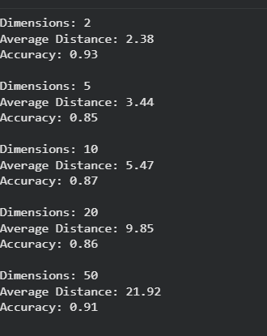
Result
As the number of dimensions increased, the average distance between data points also increased, while the classification accuracy gradually decreased. This demonstrates the Curse of Dimensionality, where higher-dimensional data becomes more difficult for machine learning algorithms to process effectively.

